Programming for Computer Games

MCAST | andre.coleiro.a106265@mcast.edu.mt

Assignment 1

andre coleiro

2017

**Question 1 (AA1, AA2)**

1. Select 2 game engines and list four reasons why one particular game engine was selected (giving advantages of the game engine) and why the other was not selected.

**Answer:**

2 Game Engines:

* Unity
* Construct 2

**I choose Unity**

1. I selected Unity instead of Construct 2 because it’s more flexible as you need to have a script with C# for your game and in Construct 2 you don’t need any script only to Drag and Drop.
2. With the free Unity license, you can develop a mobile game while Construct 2 you need to pay for the Personal License or Business Licence.
3. In Construct 2 you can use only 100 Events in the project meanwhile in Unity, you don’t have any events as you use C# to control your game and you can create many as you want scripts even in the free license.
4. In Construct 2 free license you have a limitation where you can only create four layers. In Unity free license you can create as many as you want layers.
5. Select two programming languages used in game development and choose one to support the game engine chosen and list 4 of its features.

**Answer:**

2 Programming Languages:

* C#
* Java

**I choose C#**

1. C# supports language interoperability as it is a .NET language.
2. The classes in C# are grouped in Namespaces.
3. C# can be used with Unity Engine.
4. Methods in C# are not virtual by default. This can affect the performance.

**Question 2 (SE1)**

Prepare detailed design documents for the game:

1. One Game design document (State Diagram) should contain an overview of the whole game, from the Start Menu till the end showing correctly the interactions between the scenes

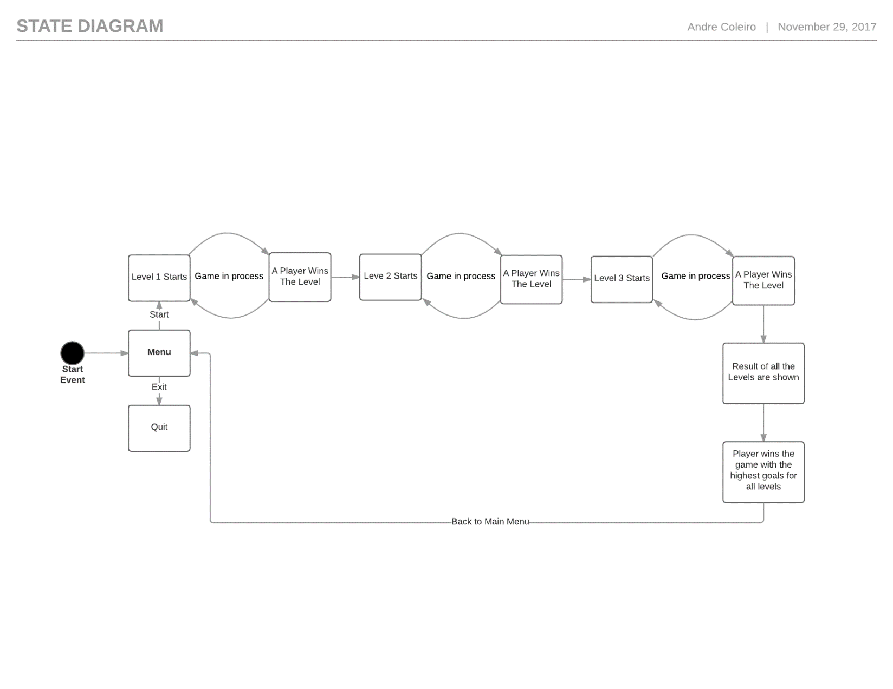

1. The second design document should contain a detailed State Diagram of either Level 2 or Level 3 of the game showing correctly all events and interactions happening in the scene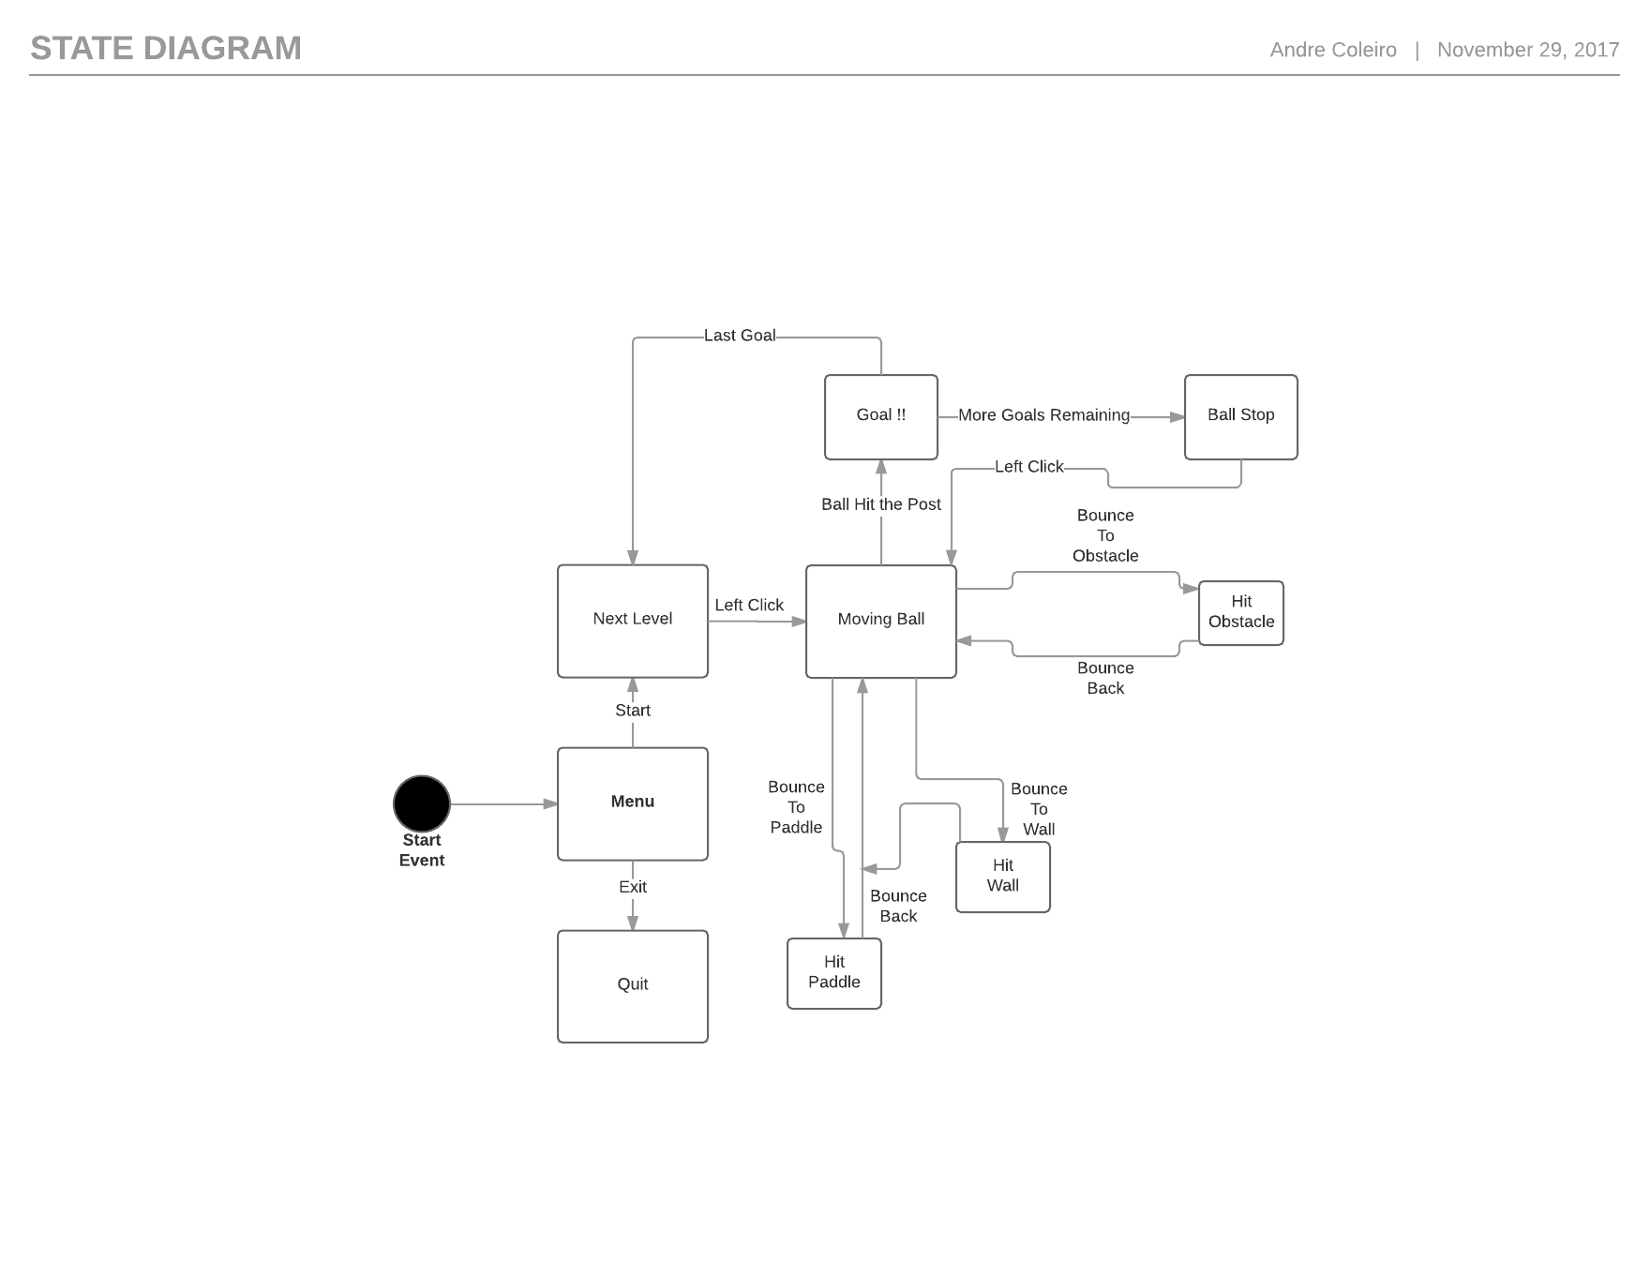

**Question 3 (KU 4)**

In not less than 100 words, explain why compression is needed when using

media assets such as images, videos, and audio. Provide examples.

**Answer:**

In media one of the most important things is compression. Compression is essential so that all the assets reduce the amount of space as this will help you from taking too much space on your hard drive because of images, videos, and audio takes too much space when they are not compressed. Although specific Images, Videos, and audio may lose some quality, this will be barely noticeable. Also, this can be a positive thing because the transfer speed is faster when transferring media files from the hard drive to the program where the media assets are going to be used.

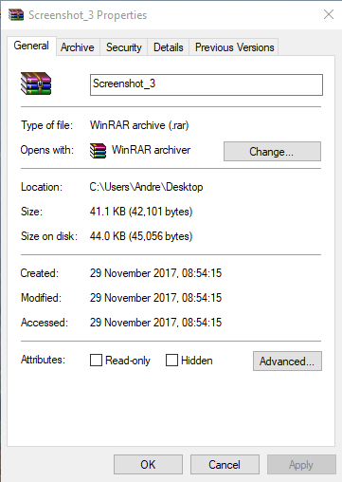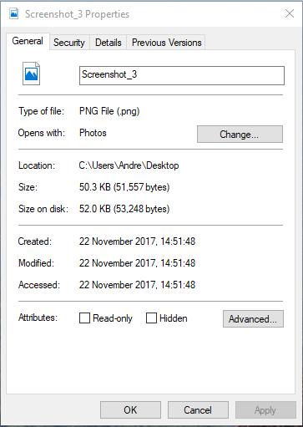**Un Compressed PNG Compressed PNG**